**Lab # 06**

**OBJECT**

***Configure Redistribution between RIP & OSPF***

**TOPOLOGY:**

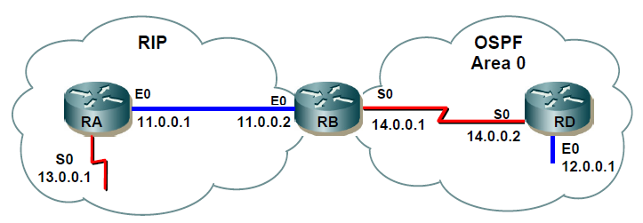

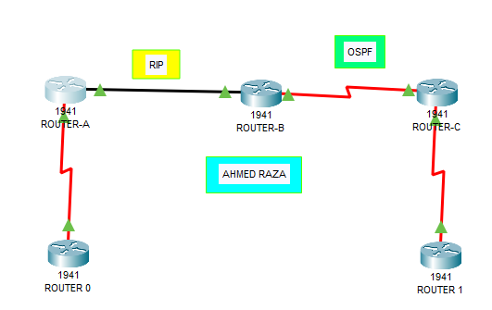

**LAB TASK:**

**Part 1: Configure Basic Settings on the Router A, B & Router C**

**Router-0:**

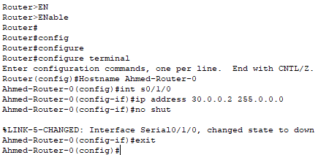

**Router A:**

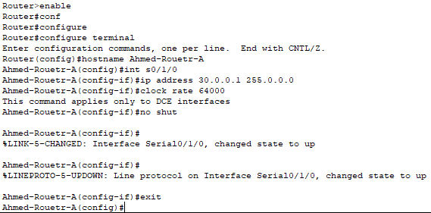

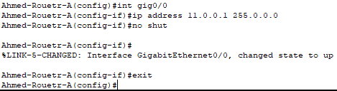

**Router B:**

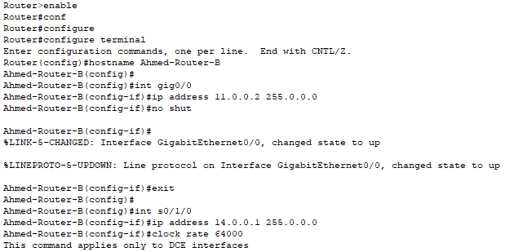

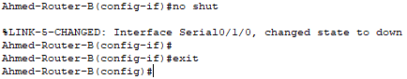

**Router C:**

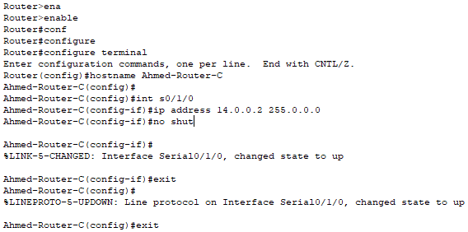

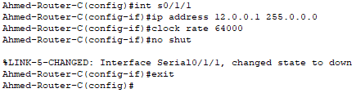

**Router 1:**

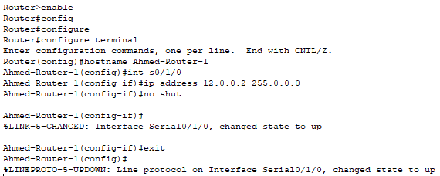

**Part 2: Configure RIP on the Router A & Router B**

**Router A:**

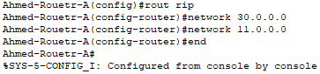

**Router B:**

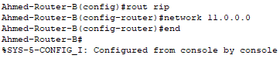

**Part 3: Configure OSPF on the Router B & Router C**

**Router B:**



**Router C:**

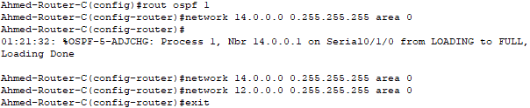

**Part 4: Configure Redistribution from RIP to OSPF and OSPF to RIP**

**Router B:**

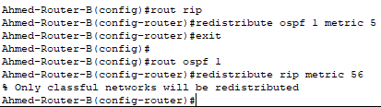

**Router C:**

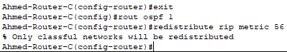

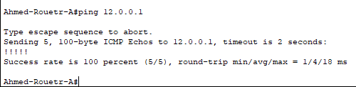

**Answer the following questions regarding the lab you have performed:**

1. Which command will be use to verify OSPF neighborship on Router RTD?

**A.**

2. Which command will be use to verify OSPF Routing table on Router RTB?

A.

3. Which command will you use to verify redistribution on Router RTB?

**A.**

4. Why do we need redistribution?

A. Route redistribution is a process that allows a network to use a routing protocol to dynamically route traffic based on information learned from a different routing protocol. Route redistribution helps increase accessibility within networks.

5. What does redistribute static command do?

A. This command is executed in router configuration mode rather it be RIP, EIGRP or OSPF to redistribute local static routes into the dynamic routing process to be dynamically advertised. The metric is configured differently on a per routing protocol basis.